Deborah Barndt

ITMD 455-02: Android App

Lab 5

James Papademas

3-23-17

Snapshot of Right Answer:

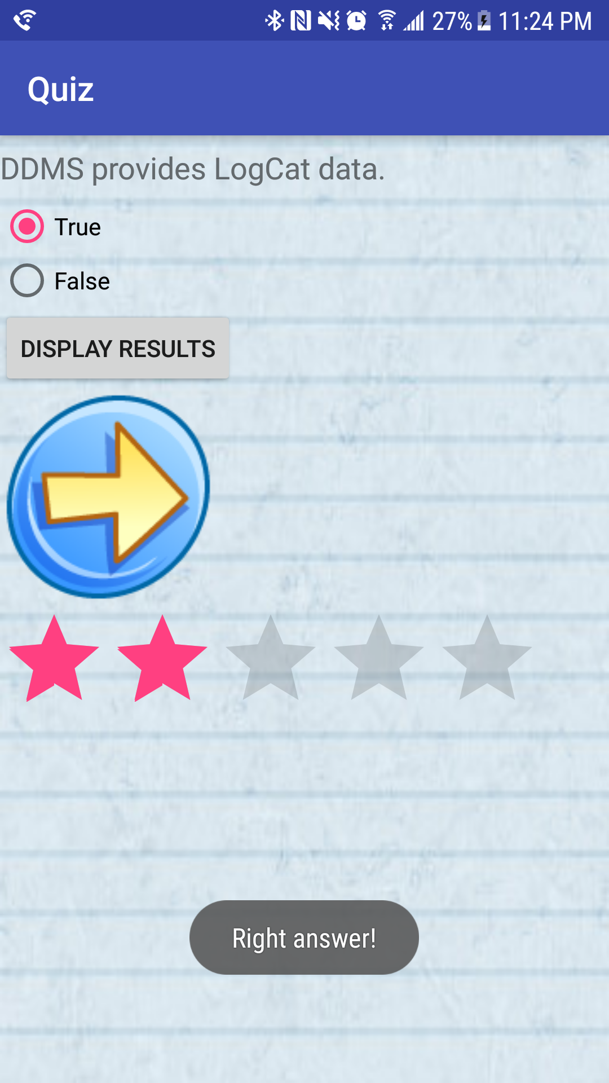

Snapshot of Wrong Answer:

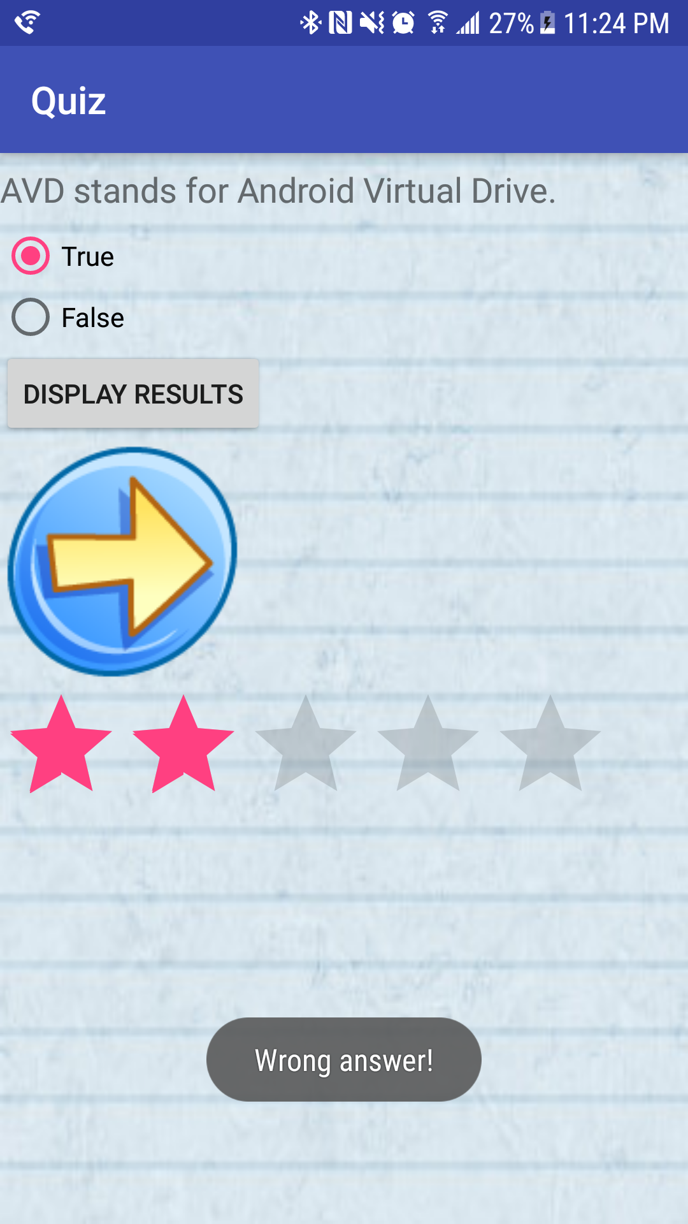

Snap of Question 3 with the answer of “Right answer!” :

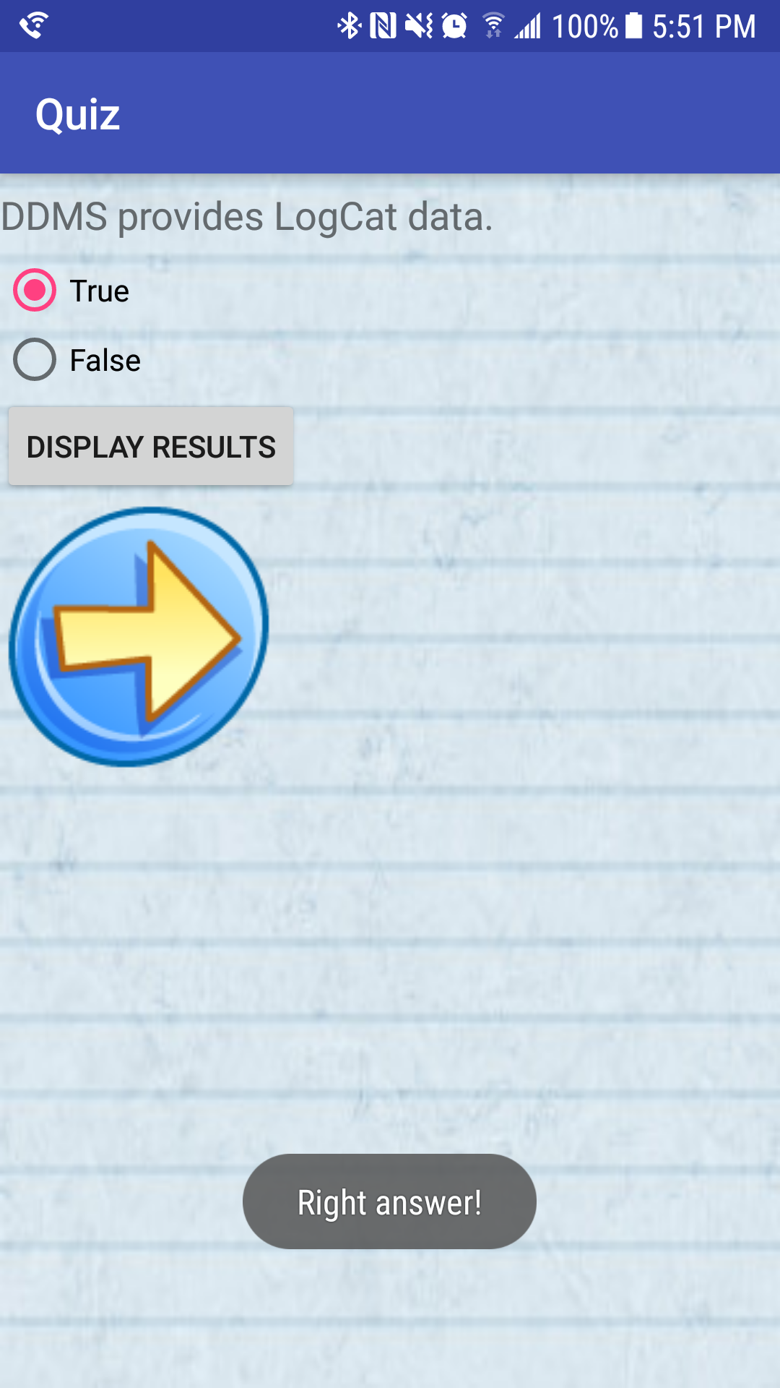

Snapshot of All Five Correct Answers (All red stars):

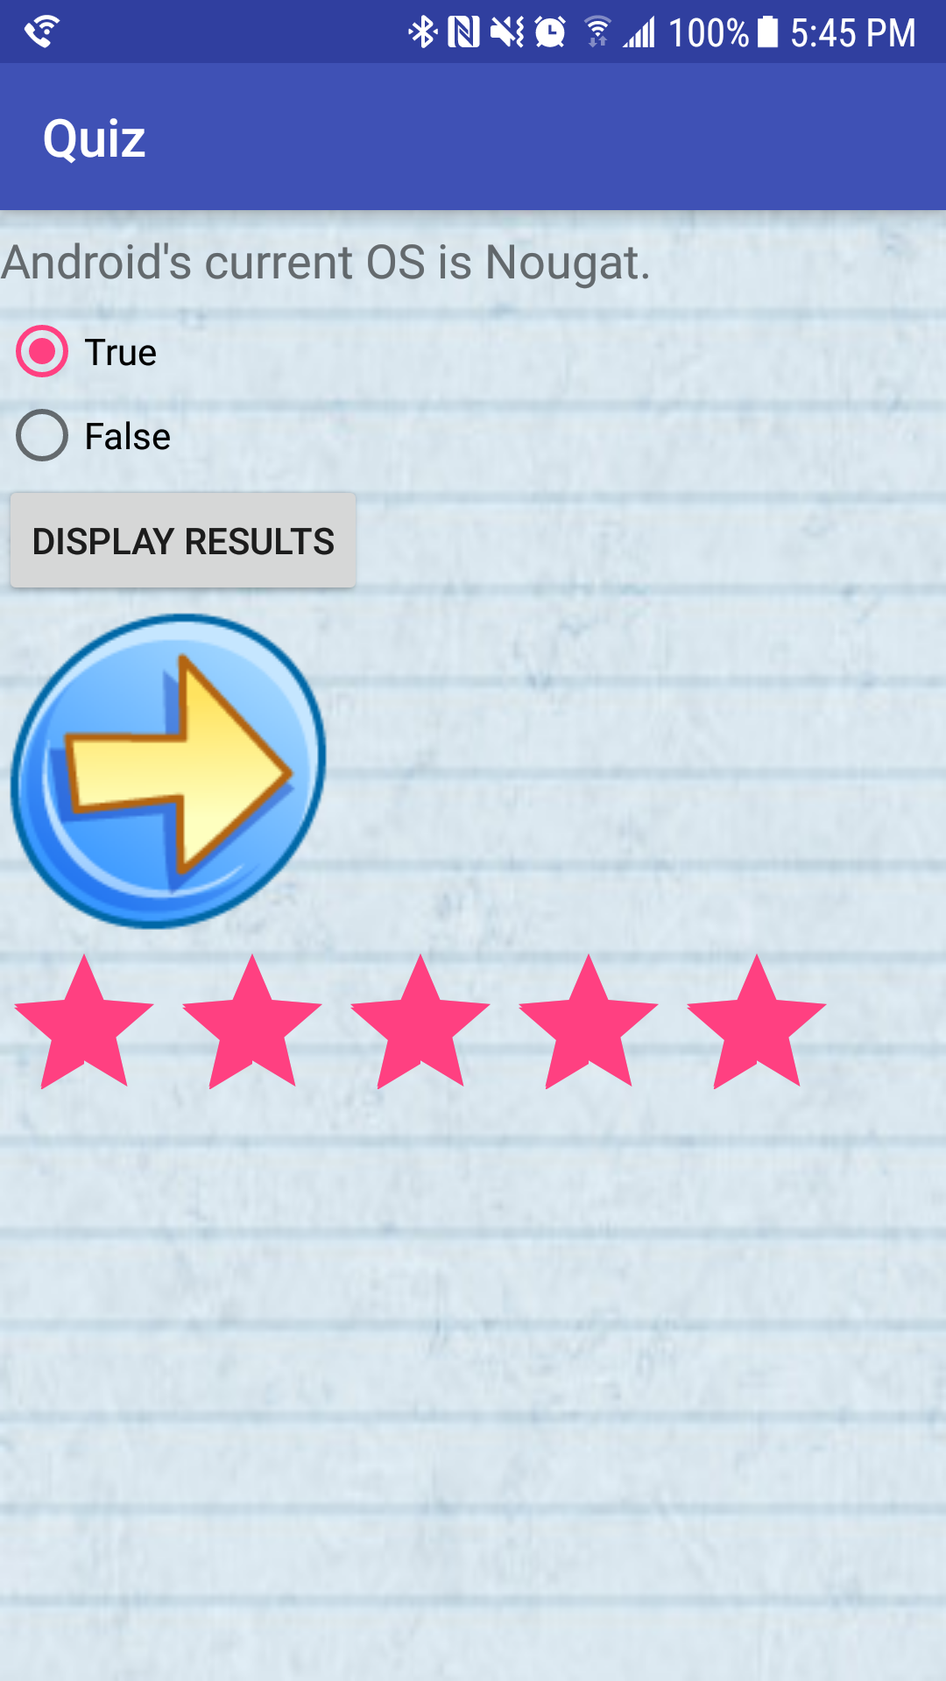

Snapshot of Differing Grey Stars:

